Classification: Official
Publication reference: RSoOCT1extension

To: NHS Community Pharmacy Contraception Service Pilot Leads, Pharmacy Commissioning teams  cc. Anne Joshua, Head of Pharmacy Integration | NHS England  Quarry House  Quarry Hill  Leeds  LS2 7UE  31 August 2022
Dear Pilot team Leads
Extension of the NHS Community Pharmacy Contraception Service Pilot: Tier 1 – Repeat Supply of Oral Contraceptives, until 31 March 2023
Thank you to all community pharmacies and their teams for their participation in the NHS Community Pharmacy Contraception Service Pilot (Tier 1). Your ongoing support and involvement in the pilot is much appreciated.
I am writing to inform you that following an interim review including positive feedback from patients and pharmacy teams it has been decided to extend Tier 1 of the Pharmacy Contraception Service pilot until 31 March 2023.
All other existing arrangements for participating in the pilot will remain in place during the pilot’s extended period.
It is not our intention to reissue formal documents with the revised pilot extension date. This letter, therefore, acts as formal notification of the date change and should sit alongside the previously circulated documents.
I would be gratefully if you would inform the participating pilot sites and community pharmacies in your areas, of this decision. It will be assumed that all pharmacies that signed up to the original SLA will continue their participation in the pilot unless they give notice as set out in the documentation.
Yours sincerely,
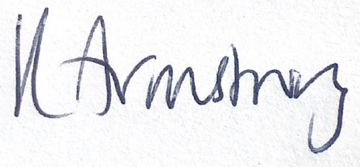
Kirsty Armstrong, Pharmacy Contraception Service Pilot Lead.
Kirsty Armstrong
Pharmacy Integration Lead
Pharmacy Integration, Primary Care Strategy and NHS Contracts
Primary Care, Community Services & Strategy Directorate
NHS England

